Project Report

|  |  |
| --- | --- |
| Team ID | PNT2025TMID08078 |
| Project Name | A Data-driven Exploration of Apple's iPhone Impact in India |

# INTRODUCTION

* 1. **Project Overview**

The project titled “A Data-driven Exploration of Apple's iPhone Impact in India” aims to transform raw market and consumer data into meaningful visual insights. It focuses on analyzing key factors such as iPhone sales trends, consumer preferences, pricing evolution, market share, and regional adoption patterns across India.

Using Tableau and Tableau Prep Builder, this project cleans, processes, and visualizes the data through interactive dashboards and storytelling features. The result is a powerful tool that helps users understand iPhone's market dynamics, consumer behavior, and product influence in the Indian smartphone ecosystem through engaging, data-driven visuals.

* 1. **Purpose**

The purpose of this project is to:

● Provide an interactive platform to explore iPhone market data in India.

● Identify and visualize how pricing, product features, and consumer demographics influence iPhone sales.

● Help users understand market distribution trends and regional adoption patterns.

● Deliver clear, visual narratives for analytical insights using Tableau's storytelling capability.

# IDEATION PHASE

* 1. **Problem Statement**

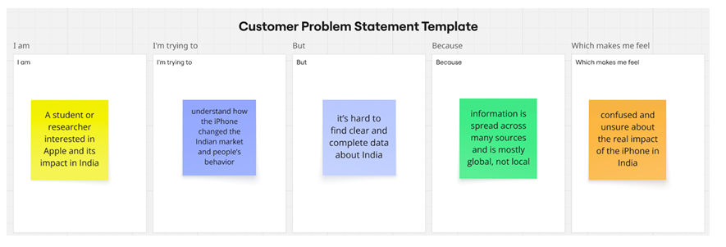

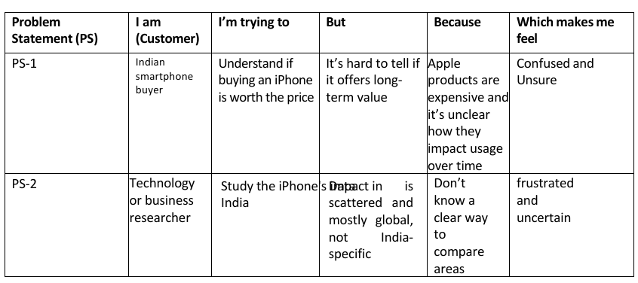

* 1. 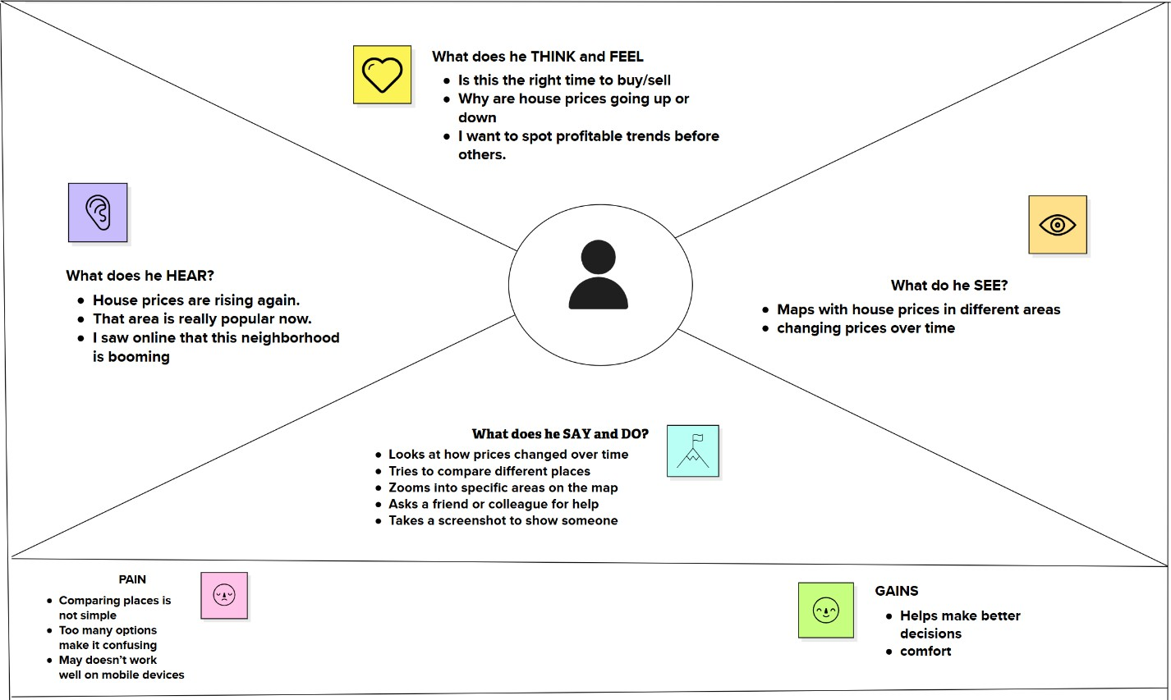 **Empathy Map Canvas**
  2. **Brainstorming**

**Step-1: Team Gathering, Collaboration and Select the Problem Statement**

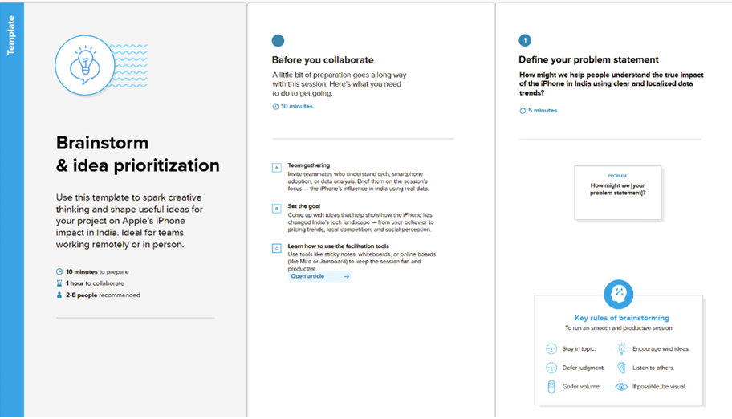

**Step-2: Brainstorm, Idea Listing and Grouping**

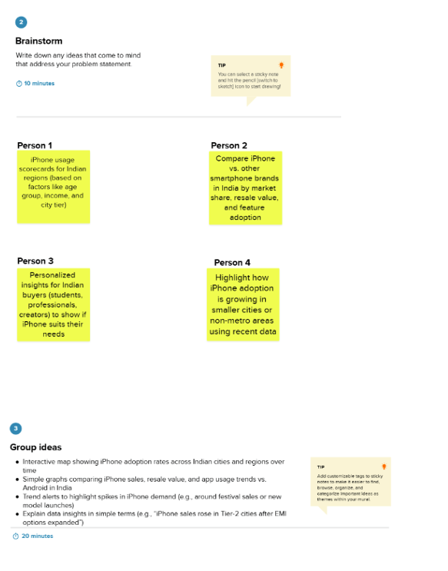

**Step-3: Idea Prioritization**

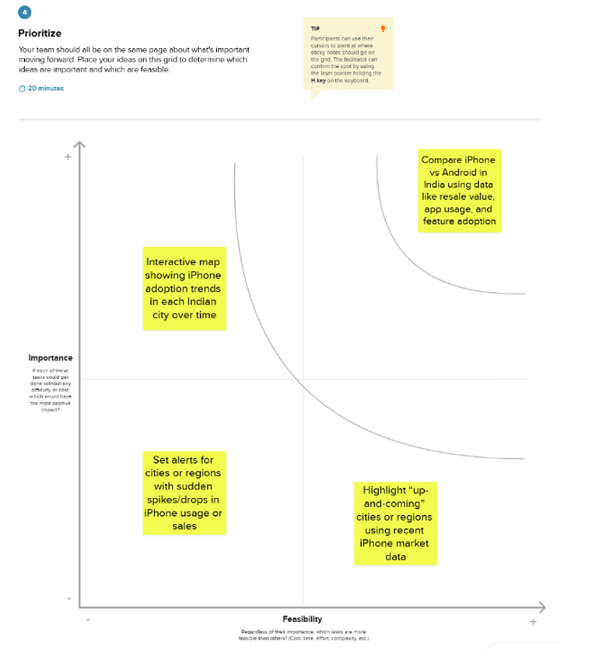

# REQUIREMENT ANALYSIS

* 1. **Customer Journey map**

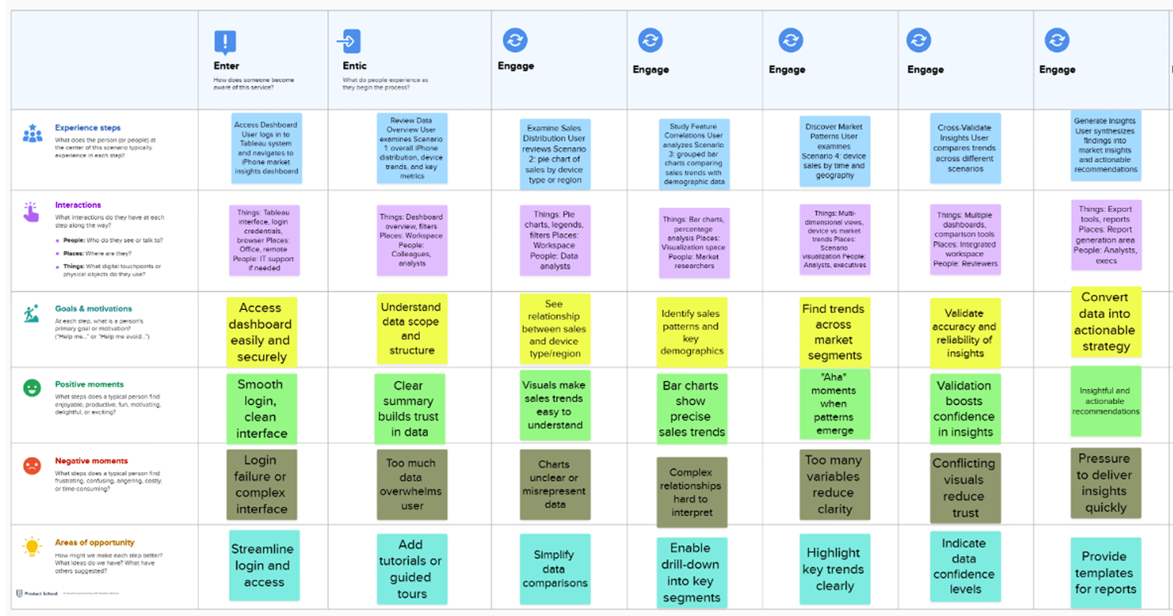

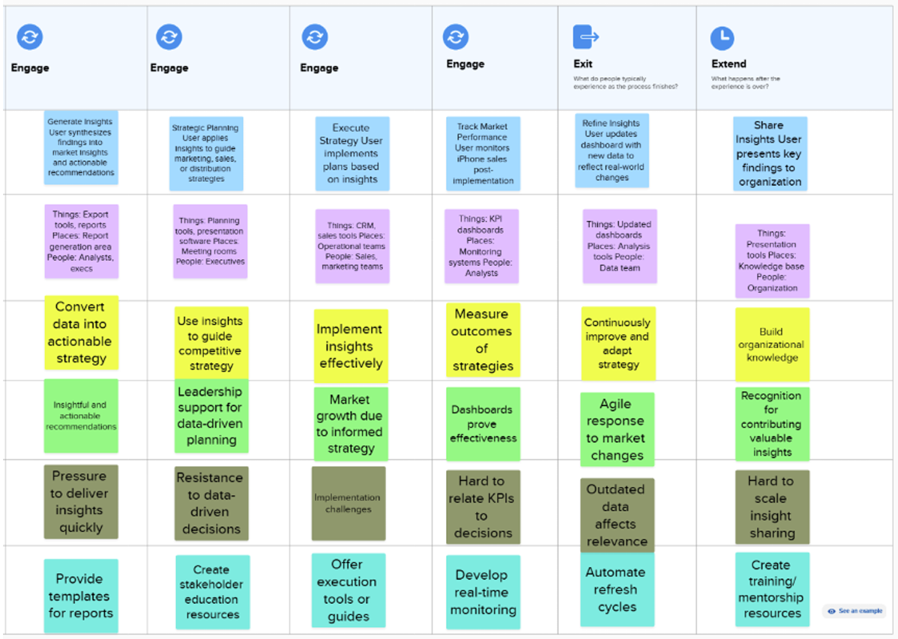

* 1. Solution Requirement

**Functional Requirements:**

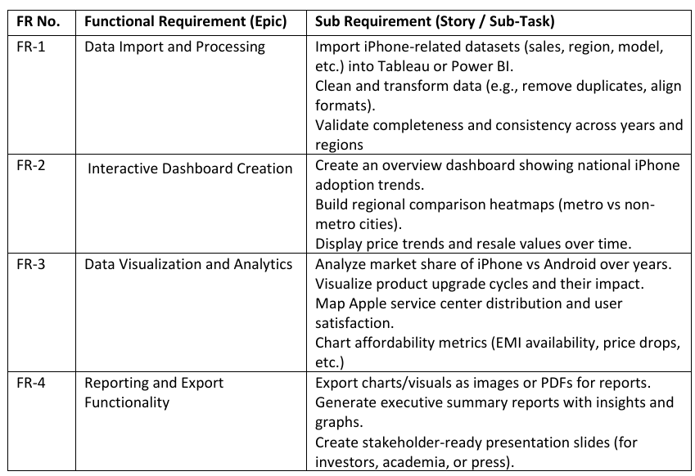

**Non-functional Requirements:**

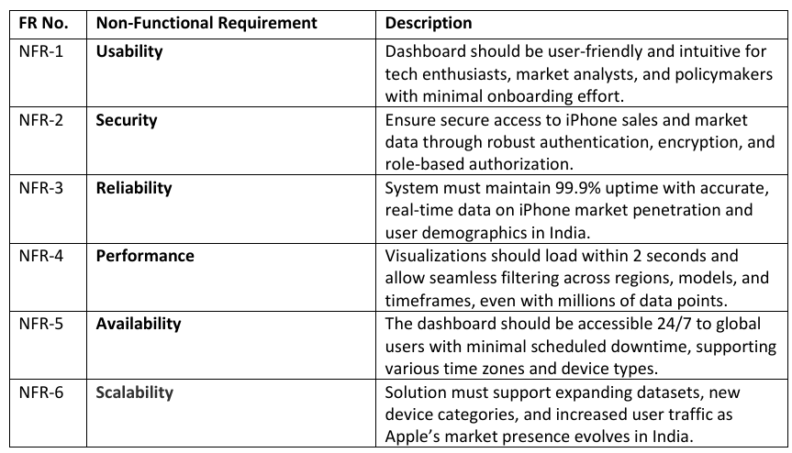

* 1. **Data Flow Diagram**

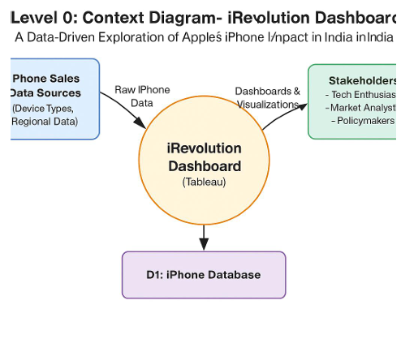

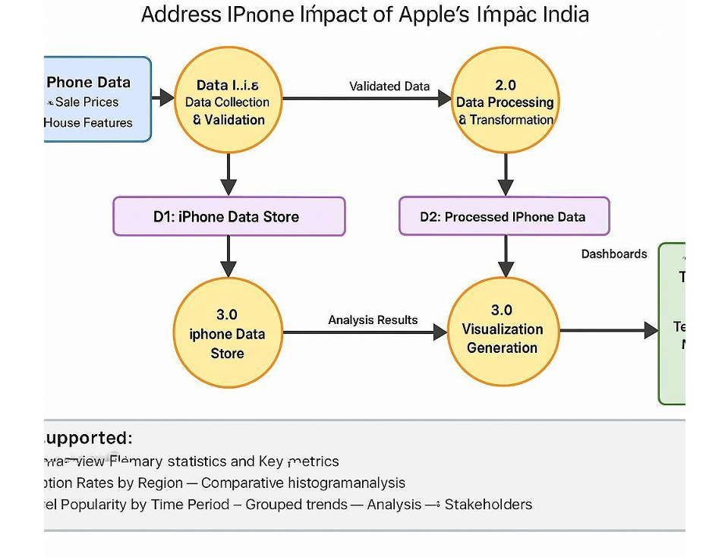

**User Stories**

Use the below template to list all the user stories for the product.

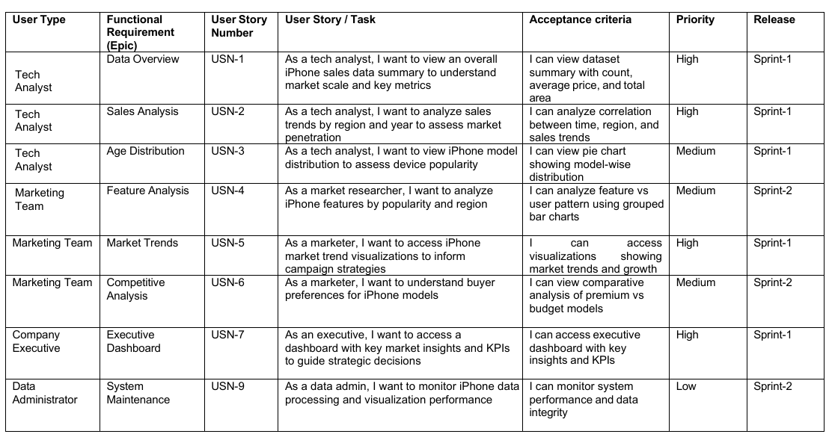

* 1. **Technology Stack**

**Table-1: Components & Technologies:**

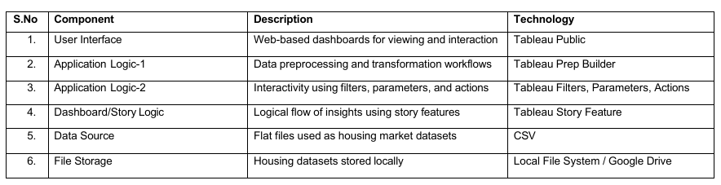

**Table-2: Application Characteristics:**

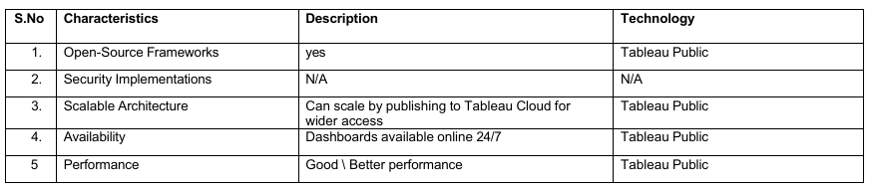

**Technical Architecture:**

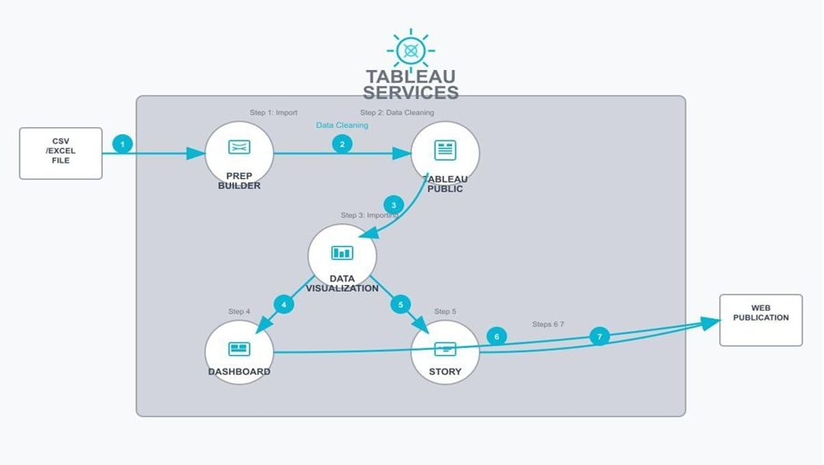

# PROJECT DESIGN

* 1. **Problem Solution Fit**

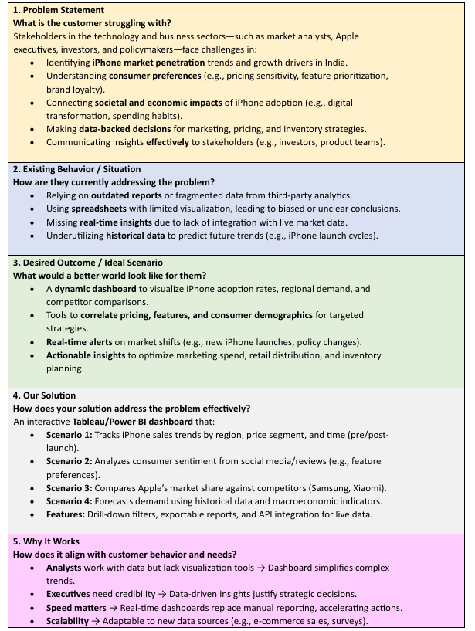

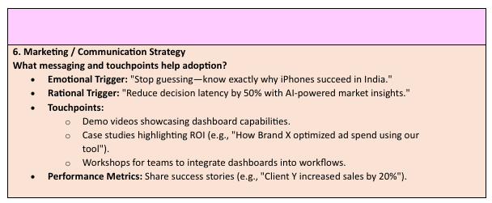

* 1. **Proposed Solution**

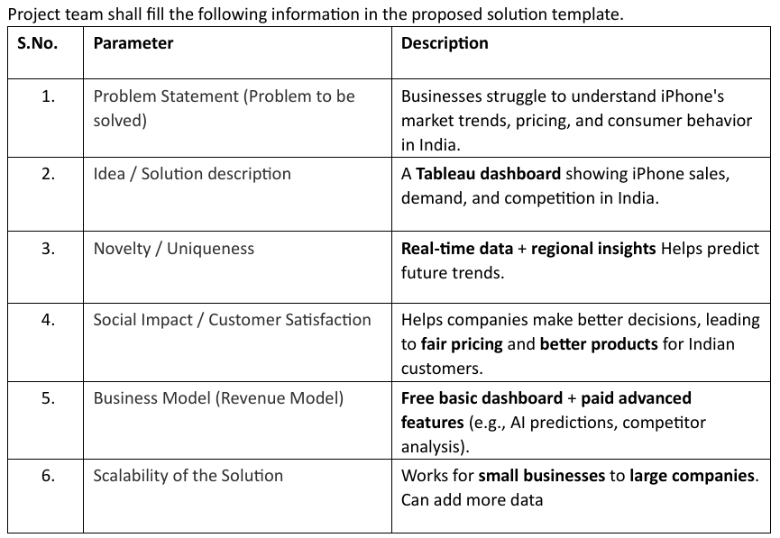

* 1. **Solution Architecture**

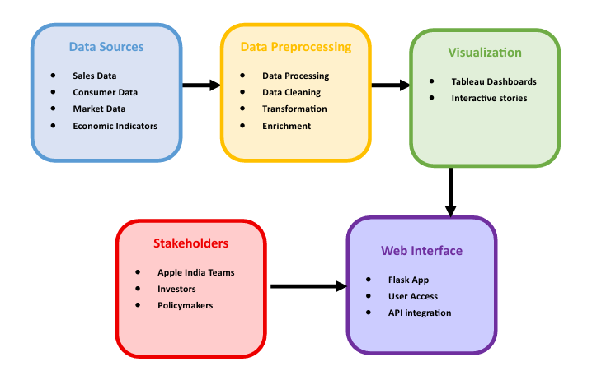

# PROJECT PLANNING & SCHEDULING

* 1. **Project Planning**

**Product Backlog, Sprint Schedule, and Estimation**

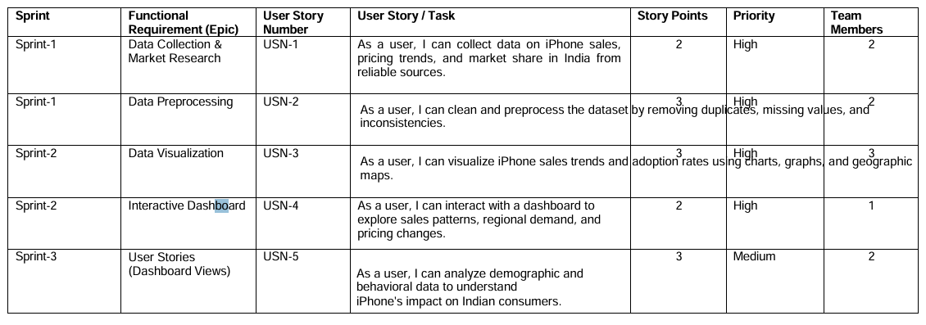

**Project Tracker, Velocity & Burndown Chart**

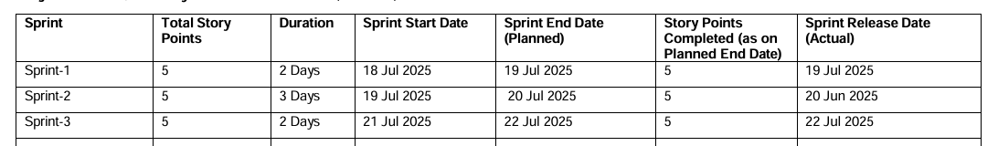

**Burndown Chart**

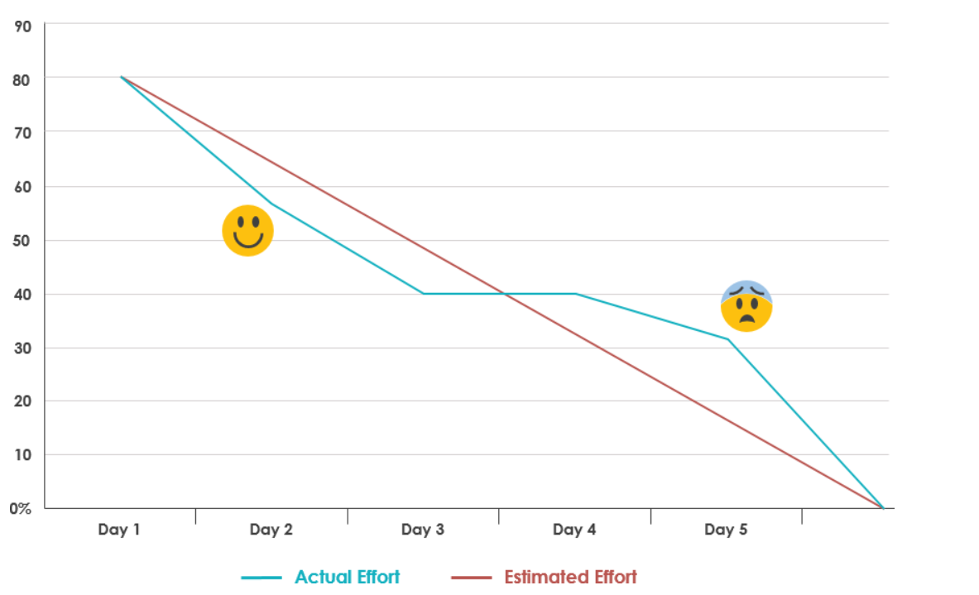

# FUNCTIONAL AND PERFORMANCE TESTING

* 1. **Performance Testing**

Project team shall fill the following information in model performance testing template.

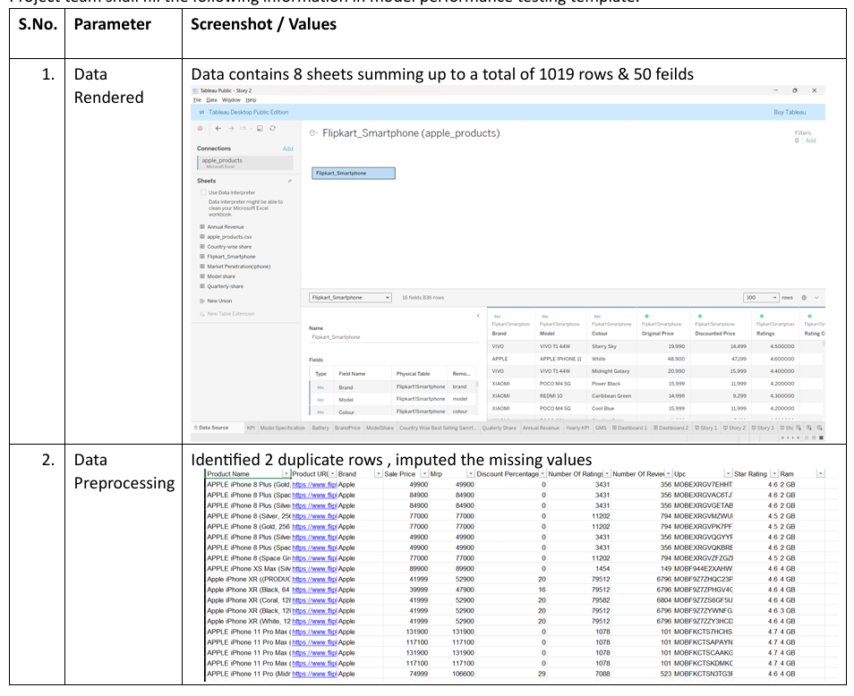

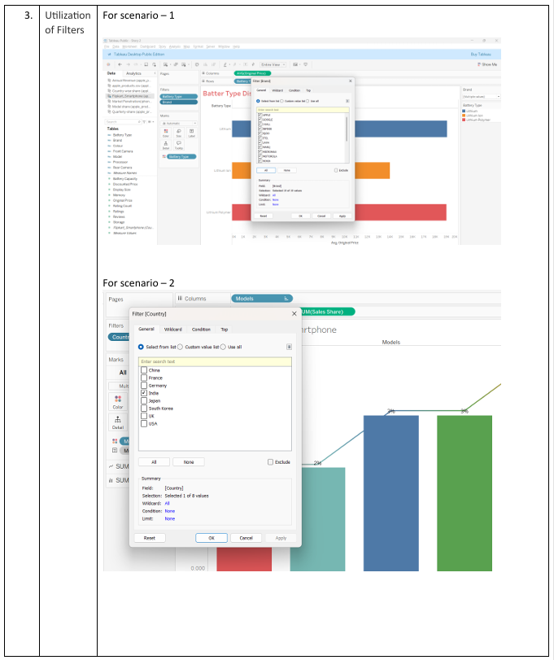

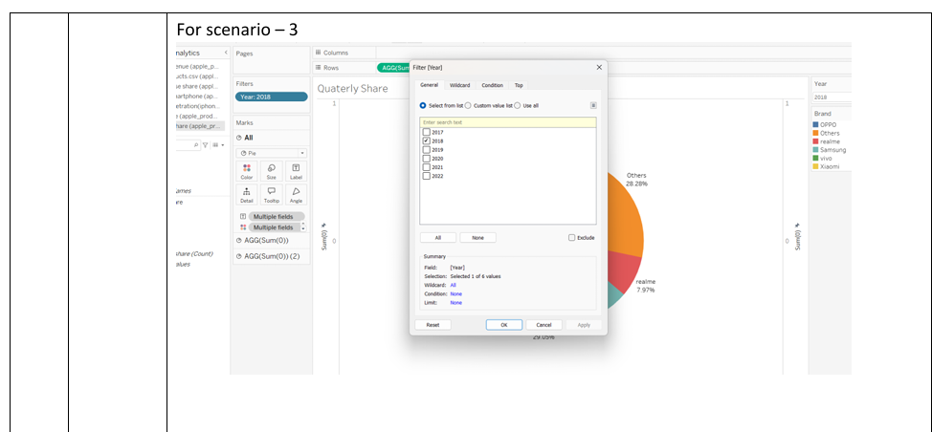

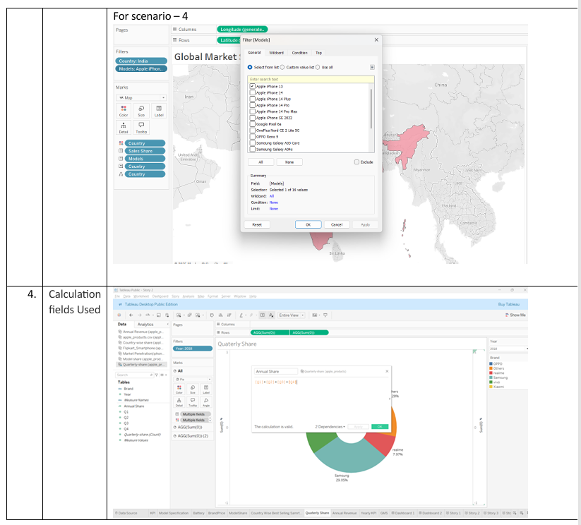

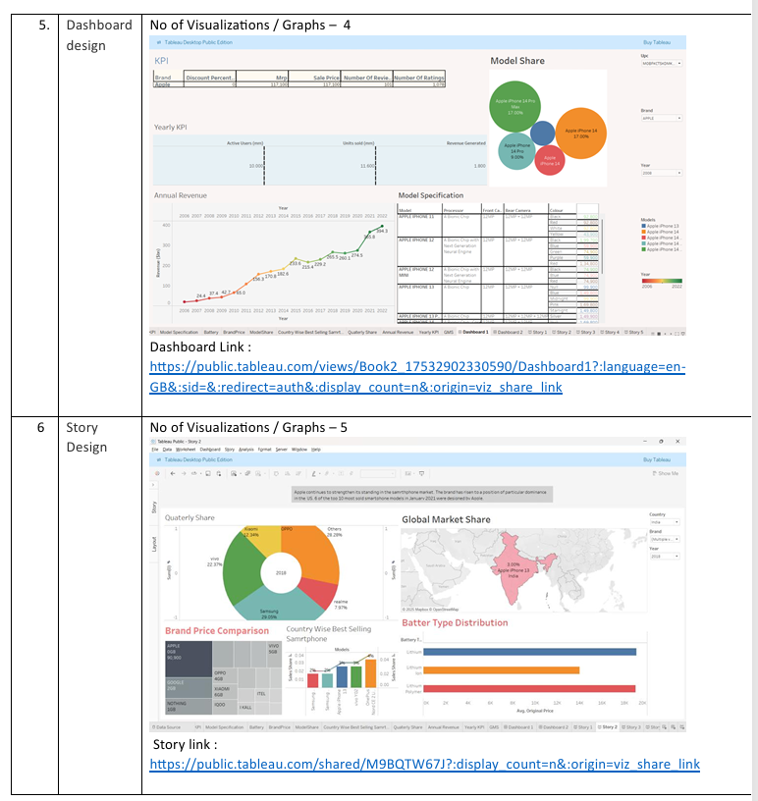

# RESULTS

* 1. **Output Screenshots**

Scenario-1

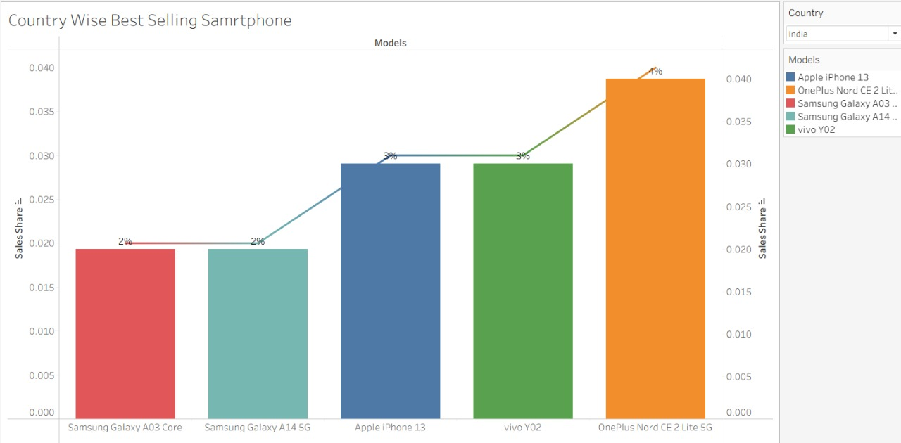

Scenario-2

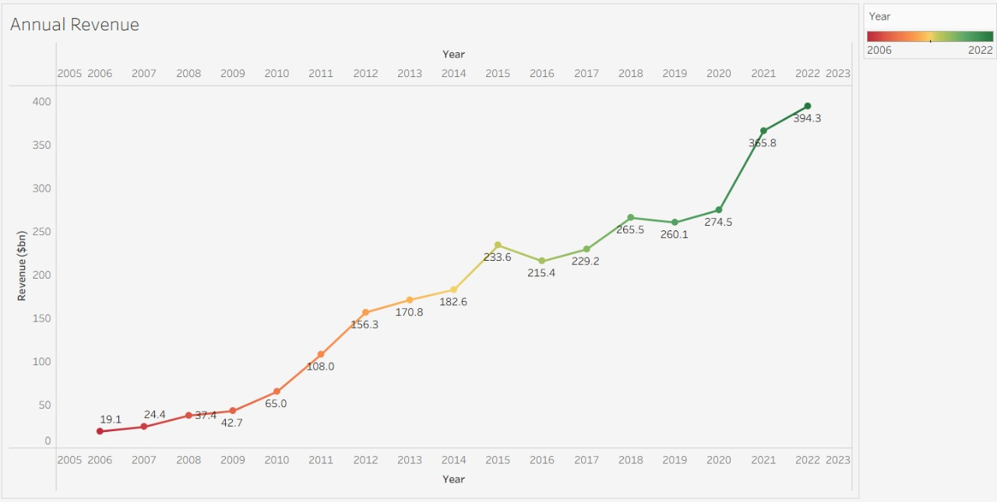

Scenario-3

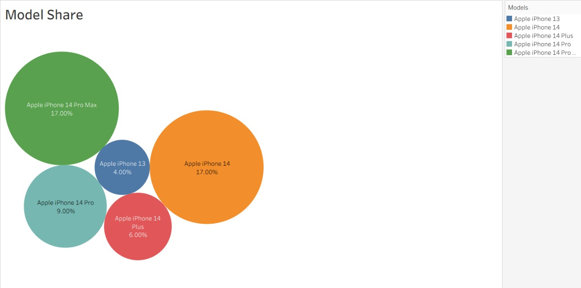

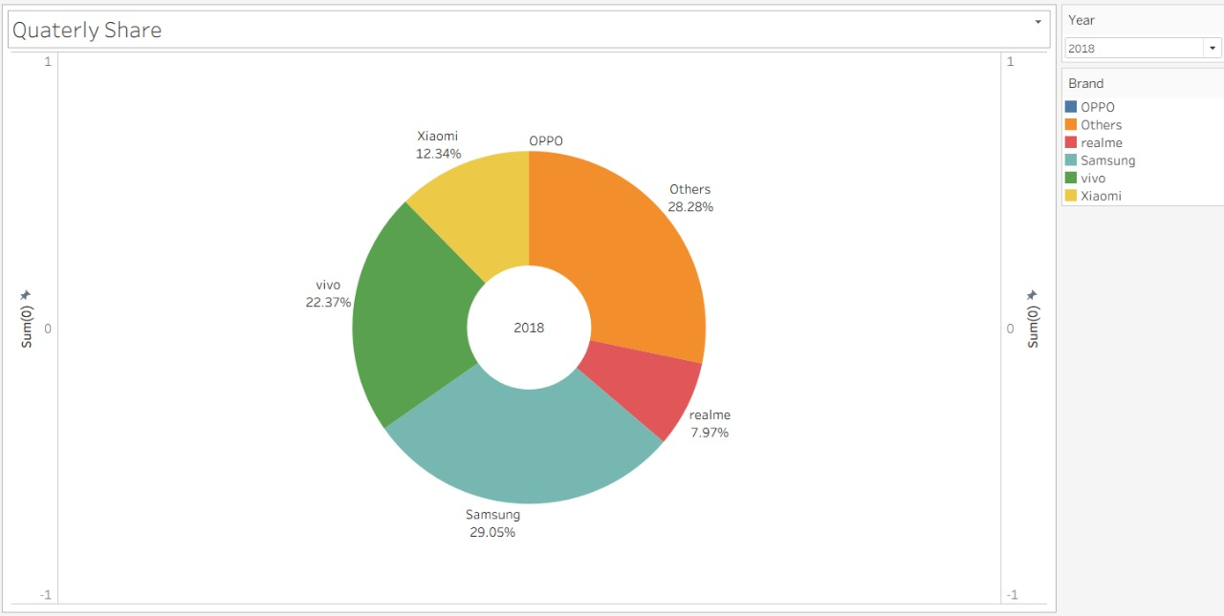

Scenario-4

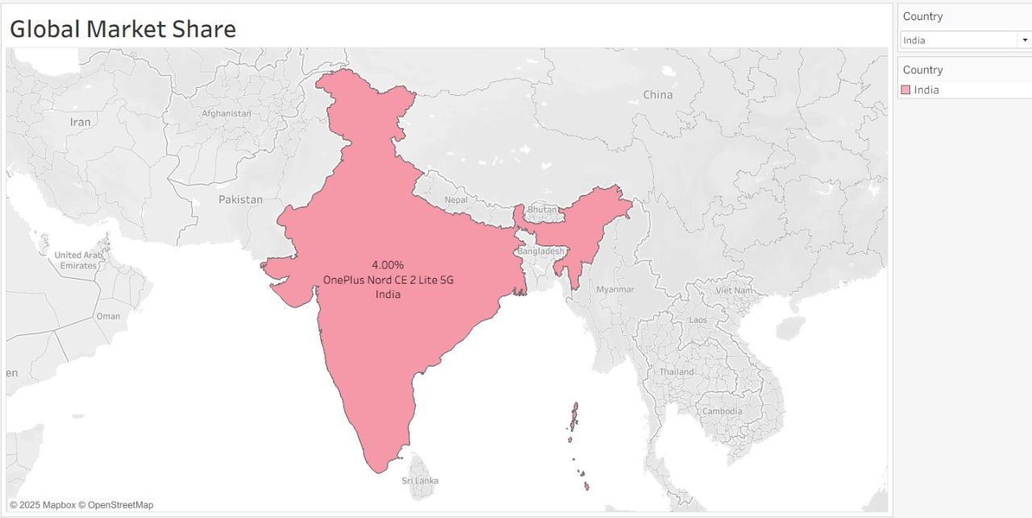

Dashboard

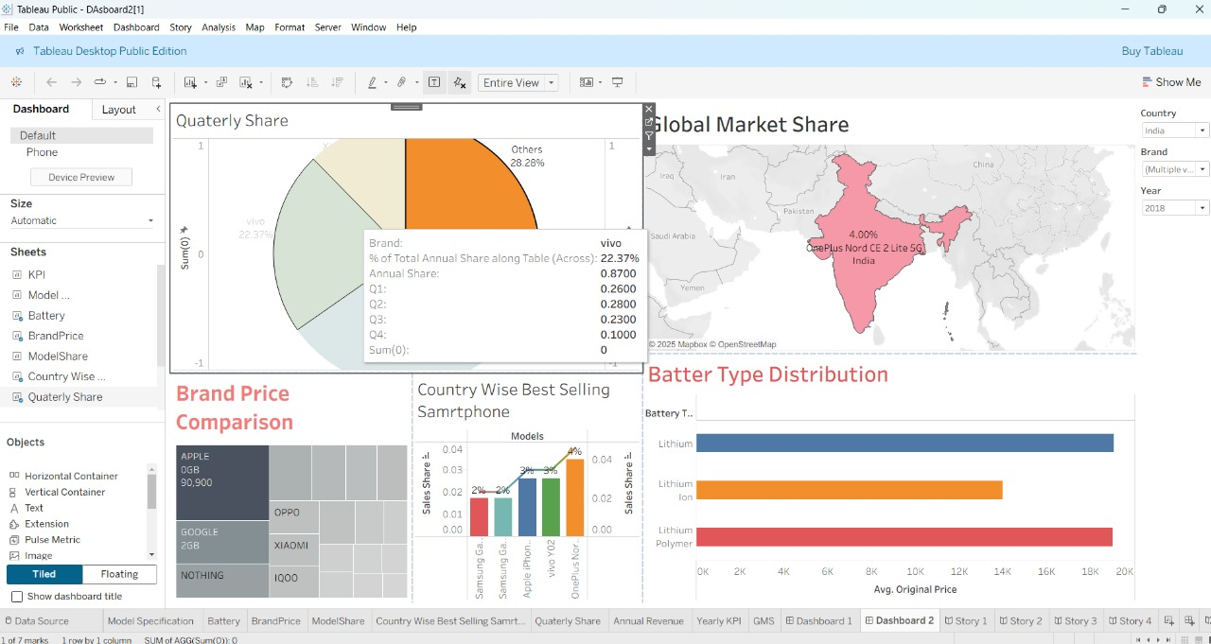

Story

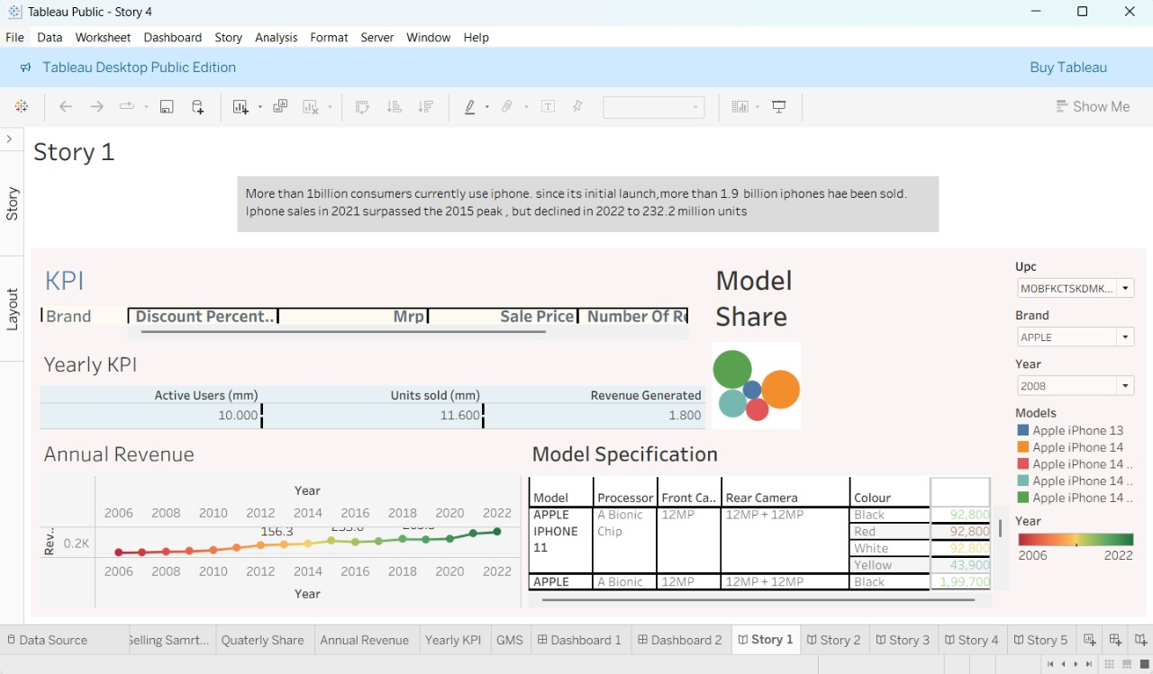

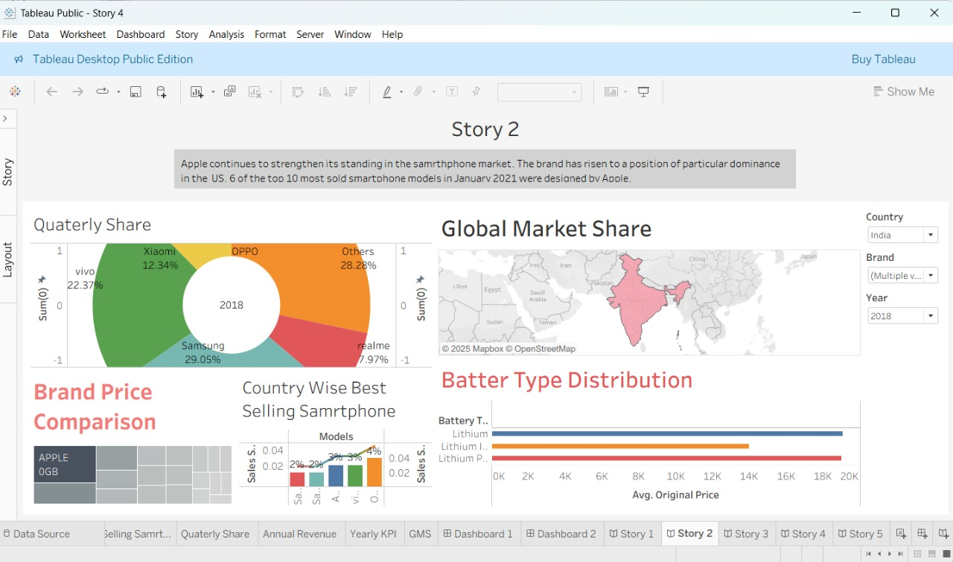

# ADVANTAGES & DISADVANTAGES

* 1. **ADVANTAGES**

1. **Clear Visuals:** Tableau shows data in simple charts and graphs.
2. **Interactive Dashboards:** Users can click and explore data by model, year, or region.
3. **Useful Insights:** Helps see trends like where and why iPhones sell more.
4. **Saves Time:** Fast analysis with less manual work.
5. **Storytelling:** Tells a clear story with data step-by-step.
6. **Easy to Use:** Even non-technical people can understand and use it.
7. **Better Decisions:** Helps companies plan better with data support.
8. **Works with Many Files:** Can use data from Excel, CSV, and online sources.

**8.2 DISADVANTAGES**

1. **No Future Predictions:** It can’t predict sales without extra tools.
2. **Needs Clean Data:** Wrong data can give wrong results.
3. **Basic Cleaning Only:** Complex cleaning needs Tableau Prep or other tools.
4. **Can Be Slow:** May slow down with large data files.
5. **Limited Stories:** Stories in Tableau are not very flexible.
6. **Costly:** Full version of Tableau can be expensive.
7. **No Live Data:** Doesn’t show real-time updates easily.
8. **Takes Practice:** You need to learn how to use it well.

# CONCLUSION

This project demonstrates the effective use of Tableau and Tableau Prep Builder to analyze and visualize Apple’s iPhone market performance in India. By examining patterns related to sales trends, pricing, consumer preferences, and regional adoption, the project offers critical insights into Apple’s evolving presence in the Indian smartphone market.

Through interactive dashboards and compelling data narratives, the project translates complex data into actionable intelligence. It highlights how visualization empowers decision-makers, marketers, and analysts to make data-driven decisions. The approach ensures insights are accessible to a wide audience, bridging the gap between raw data and strategic understanding.

# FUTURE SCOPE

1. **Add Predictions:** Use tools to guess future sales.
2. **Live Data:** Connect with real-time sales data.
3. **Use Maps:** Show which states buy more iPhones.
4. **Share Online:** Publish dashboards for teams to see.
5. **Add More Data:** Mix with other useful info like income or network coverage.
6. **Mobile-Friendly:** Make dashboards easy to use on phones.
7. **Auto-Update:** Set up to refresh data often.
8. **Custom Views:** Show different info to buyers, sellers, or managers.

# APPENDIX

Dataset Link :

<https://docs.google.com/spreadsheets/d/1p1ZWaYcEuFl5UNFcmNvpkXi3JnoHamut/edit?gid=1877446487#gid=1877446487>

Dashboard Link :

<https://public.tableau.com/views/Book2_17532902330590/Dashboard1?:language=en>

Story Link :

<https://public.tableau.com/shared/M9BQTW67J?:display_count=n&:origin=viz_share_link>

Project Demo Lin

<https://drive.google.com/file/d/1T0GZEivxXbg9HlnctpyagDtSkV0laL02/view?usp=sharing>

Project GitHub Link :